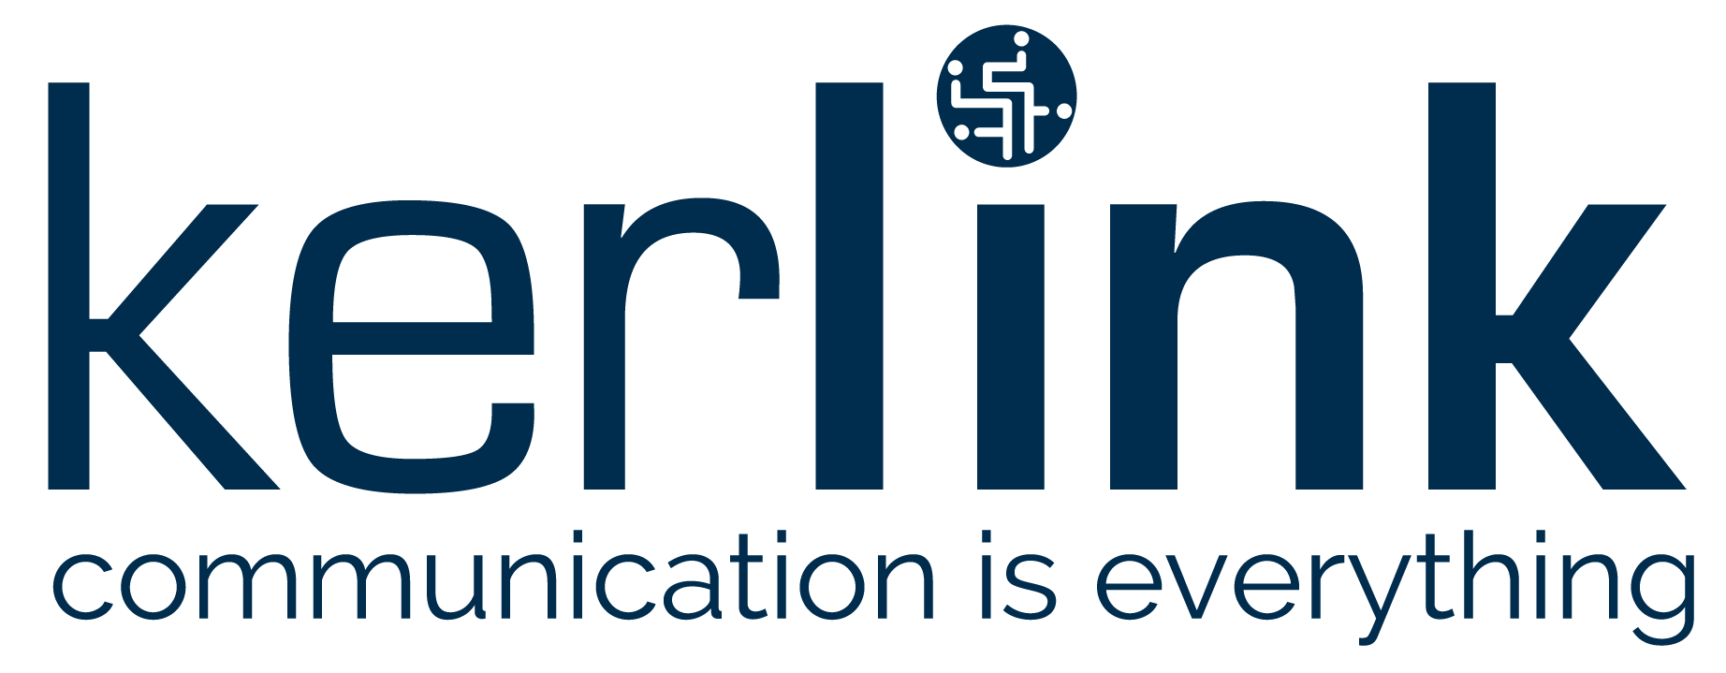

PRESS RELEASE

Thorigné-Fouillard and Sèvres, France – Nov. 14, 2019, 6:00 pm CET – Kerlink (AKLK – FR0013156007), a specialist in solutions dedicated to the Internet of Things (IoT), and Objenious (Bouygues Telecom IoT Business Unit), today announced that Kerlink’s Low Power IoT Reference Design has been certified on Objenious’s LoRaWAN® network.

Kerlink LP IoT Reference Design is a complete package of hardware, software, tools, and recommendations for prototyping and producing final products easily and quickly. It offers end-device designers, software developers, architects, and operation engineers step-by-step directions for quickly conceiving and producing IoT connected devices that offer high performance and resilience, low-energy consumption, optimized radio performance, robustness, and reliability in the field, based on the latest specifications and standards.

Objenious’s certification is a technical validation of the proper functioning of sensors based on this reference design on its LoRaWAN® networks. Engineers from Objenious provide recognized and strong expertise, including intensive RF tests.

Device makers who are developing sensors for French IoT networks will accelerate their time-to-market because they will be assured that their devices will be automatically pre-certified on Objenious networks.

“Third-party validation of Kerlink’s products and solutions is a pillar of our business model because it assures our customers and distribution partners of Kerlink offerings’ reliability and robustness,” said Guillaume Boisgontier, Kerlink’s innovative products & solutions marketing manager. “Receiving the Objenious network certification is another step in our day-to-day mission to help LoRaWAN® device makers focus on their own expertise with confidence in our products’ radio performance and connectivity.”

“With this step forward, we accelerate and send a strong and clear message to the LoRaWAN® ecosystem and partners. We aim to facilitate and increase the ROI of our LoRaWAN® partners by reducing notably time to market,” said Bernardo Cabrera, head of the Bouygues Telecom Business Unit for IoT (Objenious). “Kerlink’s reference design certification and inclusion in Objenious’s catalog offers LoRaWAN® device makers, solution makers, and integrators a proven and complementary solution for simple, reliable, and cost-effective deployments. They can rely on Objenious expertise and offer by ordering this Kerlink product directly from our catalog. Our customers have thus the confidence and the assurance of acquiring a fully tested, validated, and certified solution.”

Kerlink’s reference design is certified by the LoRa Alliance®, the world’s fastest-growing technology alliance. The non-profit association of more than 500 member companies is committed to enabling large-scale deployment of Low Power Wide Area Networks (LPWAN) for the IoT through the development and promotion of the LoRaWAN open standard global certification. Kerlink and Objenious are founding members of the alliance.

About Kerlink
Kerlink Group is a leading global provider of connectivity solutions for designing, launching, and operating public & private Internet of Things networks. Its comprehensive product portfolio includes industrial-grade network equipment, best-of-breed network core, operations and management software, value-added applications and expert professional services, backed by strong R&D capabilities. Kerlink specializes in enabling future-proof intelligent IoT connectivity for key verticals such as fleet management, transportation & logistics, retail, asset tracking, and smart metering, as well as smart agriculture & environment, and smart cities, buildings, and factories. More than 120,000 Kerlink installations have been rolled out with more than 330 clients in 69 countries. Based in France, with subsidiaries in the US, Singapore, India, and Japan, Kerlink is a founding and board member of the LoRa Alliance® and the uCIFI Alliance™. It is listed on Euronext Growth Paris under the symbol AKLK.
For more information, visit www.kerlink.com or follow us on Twitter @kerlink_news.

About Objenious
Objenious, Bouygues Telecom brand dedicated to the Internet of Things, supports all businesses and communities in their digital transformation through offers and services based on its LoRaWAN®, 2G, 3G, 4G and soon 5G networks. Objenious experts guide large companies in their reflection and the implementation of their IoT projects and offer with a broad ecosystem of partners solutions adapted to all sectors of activity such as electronic banking, automotive, energy, security, building, distribution, maintenance or transport and logistics.
As member of the LoRa Alliance, Objenious is reinforcing its international strategy development through this partnership. This agreement is to be one among a series that covers all stakeholders who have chosen or are willing to choose LoRa technology.
For more information, visit www.objenious.com/

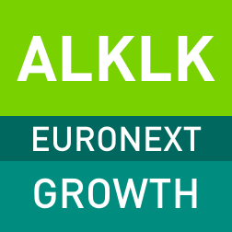
Upcoming events
2019 Revenue: 12 February 2020, after market close
www.kerlink.com

 | 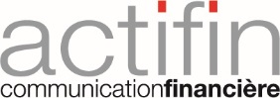
Objenious contact:  Alexandra Berry  Responsible Communication  +33 6 59 39 63 17  aberry@objenious.com | Financial press contact:  Actifin  Isabelle Dray  +33 (0) 1 56 88 11 29  idray@actifin.fr | Kerlink press and market analysts contact:  Mahoney Lyle  Sarah-Lyle Dampoux  +33 (0) 6 74 93 23 47  sldampoux@mahoneylyle.com
Investors contact:
Actifin
Benjamin Lehari
+33 (0)1 56 88 11 25
blehari@actifin.fr

www.kerlink.com Kerlink @kerlink_news Kerlink

