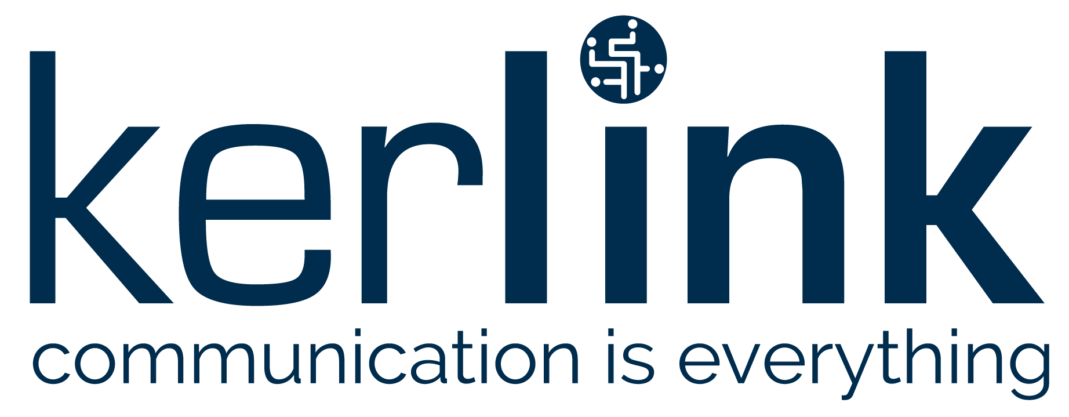

PRESS RELEASE

New Delhi – Oct. 17, 2019, 08:00a.m. CEST – Kerlink (ALKLK - FR0013156007), a specialist and global leader in solutions dedicated to the Internet of Things (IoT), and SenRa, a PAN India Low-Power Wide-Area Networks (LPWANs) provider for long-range-based (LoRa®-based) IoT applications, today announced their partnership to reach a target of 100 smart-city networks in India by the end of 2020.

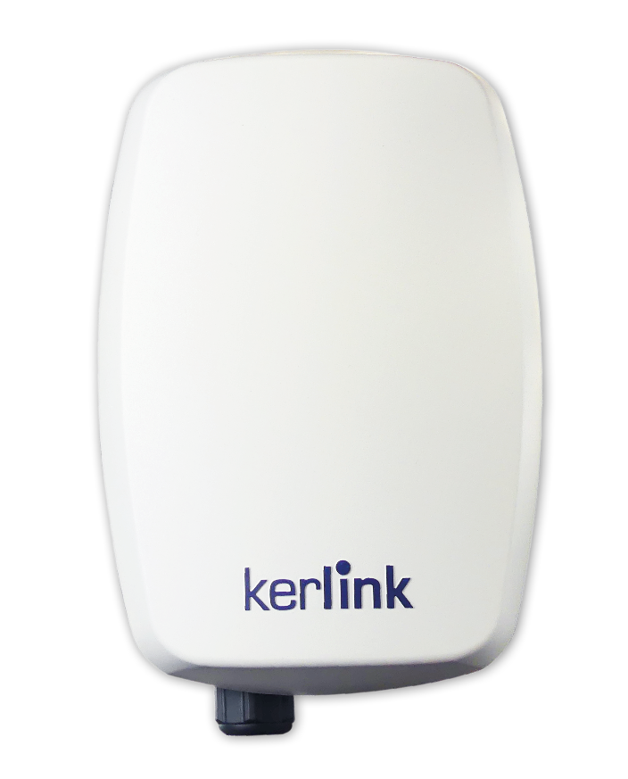
Building on a smart-city initiative launched by SenRa, called Smart City Mission, the new roll outs will rely on Kerlink products and solutions. These include the company’s new industrial-grade WirnetTM iStation with fully integrated internal antennas and 4G backhaul connectivity, and Wirnet iFemtoCell gateway, designed for deep indoor applications.

The collaboration was announced during LoRaWAN® Live in New Delhi, a full-day event focused on advancing business opportunities in the IoT and highlighting why LoRaWAN® is widely recognized as the de facto LPWAN technology.

“Kerlink is a global leader in delivering high-performance, robust and reliable IoT networks in any environmental conditions, including India’s monsoon season,” said SenRa CEO & founder Ali Hosseini. “In addition, the company’s package of highly consistent, future-proof and compact range of solutions enables quick network deployment, update and overall operation.”

“Wirnet iStation is a unique, robust, and reliable IoT gateway that is ideal for outdoor IoT connectivity,” said Girish Dadheech, vice president of Kerlink India. “Its combination of simple installation, superior technical characteristics, and weather-hardened design is a perfect fit for SenRa’s smart-city program.”

India Government’s Smart City Mission was launched to create a more sustainable and citizen-friendly India. SenRa’s LoRaWAN® networks are dedicated to supporting smart city projects such as parking, waste management, street lighting, and utilities. SenRa and Kerlink are on track to deploy public LoRaWAN® networks in 100 cities by the end of 2020, building on SenRa’s earlier deployments this year.

About Kerlink Group
Kerlink Group is a leading global provider of end-to-end network solutions for the Internet of Things (IoT), serving telecom operators, businesses, and public authorities worldwide. Based in Thorigne-Fouillard, France, with a U.S. subsidiary in Chicago, Kerlink is a leading global provider of LoRaWAN® network equipment, software, and services. Its growing suite of turnkey IoT services includes network planning, design, and operational management that maximizes performance of its market-leading, carrier-grade infrastructure offering. The Group, widely recognized for its IoT expertise, also continually introduces innovative value-added services, such as network-based geolocation, remote end-device management and low-power IoT reference design, which allows its customers to quickly bring to market IoT-ready devices and to imagine innovative business models to monetize their deployments. Most recently, Kerlink introduced an expanded service, solution design, as part of its growing suite of services for companies and smart cities.
In just over 11 years, more than 120,000 Kerlink installations have been deployed in more than 69 countries. Kerlink is supplying more than 330 customers worldwide, including major telcos such as Tata Communications, and service providers such as GrDF and Suez. The company’s solutions are enabling major deployments in Europe, South Asia, South America, Japan, and Oceania. Kerlink, a co-founder and board member of the LoRa AllianceTM, has invested more than €16 million in R&D over the past five years. It has been listed on Euronext Growth Paris since May 2016 and entered the 150 fast-growing French SMEs “EnterNext PEA-PME 150” index in 2017. In 2018, it joined the “Tech 40 index”, which recognizes the top-performing tech SMEs on Euronext’s markets in Amsterdam, Brussels, Lisbon and Paris.
For more information, visit www.kerlink.com or follow us on Twitter @kerlink_news.

About SenRa
SenRa, a contributing member of the LoRa Alliance®, is a PAN India Low Power Wide Area Network Provider (LPWAN), specifically LoRaWAN®, for the Internet of Things (IoT) and Machine to Machine (M2M) solutions and applications. SenRa is currently deploying LPWANs throughout India for projects which require secure, reliable, long distance communication at low cost. SenRa is working with global partners to deploy smart solutions such as water metering, smart agriculture, smart lighting, logistics and gas meter. For additional information visit: https://senraco.com/.

About LoRa Alliance®
The LoRa Alliance is an open, non-profit association that has become one of the largest and fastest-growing alliances in the technology sector since its inception in 2015. Its members collaborate and share expertise to develop and promote the LoRaWAN® protocol, which is the de facto global standard for secure, carrier-grade IoT LPWAN connectivity. LoRaWAN has the technical flexibility to address a broad range of IoT applications, both static and mobile, and a robust LoRaWAN Certification program to guarantee that devices perform as specified. The LoRaWAN protocol has been deployed by more than 100 major mobile network operators globally, and connectivity is available in more than140 countries, with continual expansion.

Upcoming events
Q3 2019 Revenue: 22 October 2019, after market close
www.kerlink.com

 | 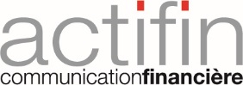 | 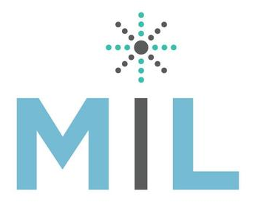
SenRa contact:  Isha Sankhyadhar  Marketing Lead  isha.sankhyadhar@senraco.com | Investors contact:  Actifin  Benjamin Lehari  +33 (0)1 56 88 11 25  blehari@actifin.fr | Kerlink press and market analysts contact:  Mahoney Lyle  Sarah-Lyle Dampoux  +33 (0) 6 74 93 23 47  sldampoux@mahoneylyle.com
Financial press contact:
Actifin
Isabelle Dray
+33 (0) 1 56 88 11 29
idray@actifin.fr

www.kerlink.com fr.linkedin.com/company/kerlink @kerlink_news

